# Microsoft Word

It is an application software developed by Microsoft Cooperation of USA. This software helps us to create and design bio-data, reports, letters, and application and so on.

Process to open

* Click on start button
* Go to all programs
* Click on Microsoft office
* Click on Microsoft office word

Or Click on start button

* Type winword
* Hit enter key

**Microsoft Word Window:**



When you begin to explore Word 2007 you will notice a new look to the menu bar. You should remember three features as you work within Word 2007:

􀂃 the Microsoft Office Button

􀂃 the Quick Access Toolbar

􀂃 the Ribbon

These three features contain many of the functions that were in the menu of previous versions of Word. The functions of these three features will be outlined below.

The Microsoft Office button performs many of the functions that were located in the File menu of older versions of Word. This button allows you to create a new document, open an existing document, save or save as, print, send (through email or fax), publish or close.



The Ribbon is the panel at the top portion of the document. It has seven tabs: Home, Insert, Page Layout, References, Mailings, Review, and View that contain many new and existing features of Word. Each tab is divided into groups. The groups are logical collections of features designed to perform functions that you will utilize in developing or editing your Word document. Commonly used features are displayed on the Ribbon, to view additional features within each group, click on the arrow at the bottom right of each group.

***Each of the tabs contains the following tools:***

**Home:** Clipboard, Fonts, Paragraph, Styles, and Editing.

**Insert:** Pages, Tables, Illustrations, Links, Header & Footer, Text, and Symbols

**Page Layout:** Themes, Page Setup, Page Background, Paragraph, Arrange

**References:** Table of Contents, Footnote, Citation & Bibliography, Captions, Index, and Table of Authorities

**Mailings:** Create, Start Mail Merge, Write & Insert Fields, Preview Results, Finish **Review:** Proofing, Comments, Tracking, Changes, Compare, Protect

**View:** Document Views, Show/Hide, Zoom, Window, Macros

**Quick Access Toolbar**

The quick access toolbar is a customizable toolbar that contains commands that you may want to use. You can place the quick access toolbar above or below the ribbon. To change the location of the quick access toolbar, click on the arrow at the end of the toolbar and click on Show Below the Ribbon.

You can also add items to the quick access toolbar. Right click on any item in the Office Button or the Ribbon and click on Add to Quick Access Toolbar and a shortcut will be added to the Quick Access Toolbar.

**Create a New Document**

There are several ways to create new documents, open existing documents, and save documents in Word:

􀂃 Click the **Microsoft Office Button** and Click **New** or

􀂃 Press CTRL+N (Depress the CTRL key while pressing the “N”) on the keyboard

You will notice that when you click on the Microsoft Office Button and Click **New**, you have many choices about the types of documents you can create. If you wish to start from a blank document, click **Blank**. If you wish to start from a template, you can browse through your choices on the left, see the choices on center screen, and preview the selection on the right screen.

**Opening an Existing Document**

􀂃 Click the **Microsoft Office Button** and Click **Open,** or

􀂃 Press CTRL+O (Depress the CTRL key while pressing the “O”) on the keyboard, or

􀂃 If you have recently used the document you can click the **Microsoft Office Button** and click the name of the document in the **Recent Documents** section of the window Insert picture of recent docs

**Saving a Document**

Click the **Microsoft Office Button** and Click **Save** or **Save As** (remember, if you’re sending the document to someone who does not have Office 2007, you will need to click the **Office Button**, click **Save As**, and Click **Word 97-2003 Documen**t), or

􀂃 Press CTRL+S (Depress the CTRL key while pressing the “S”) on the keyboard, or

􀂃 Click the **File** icon on the Quick Access Toolbar

Home Tab:

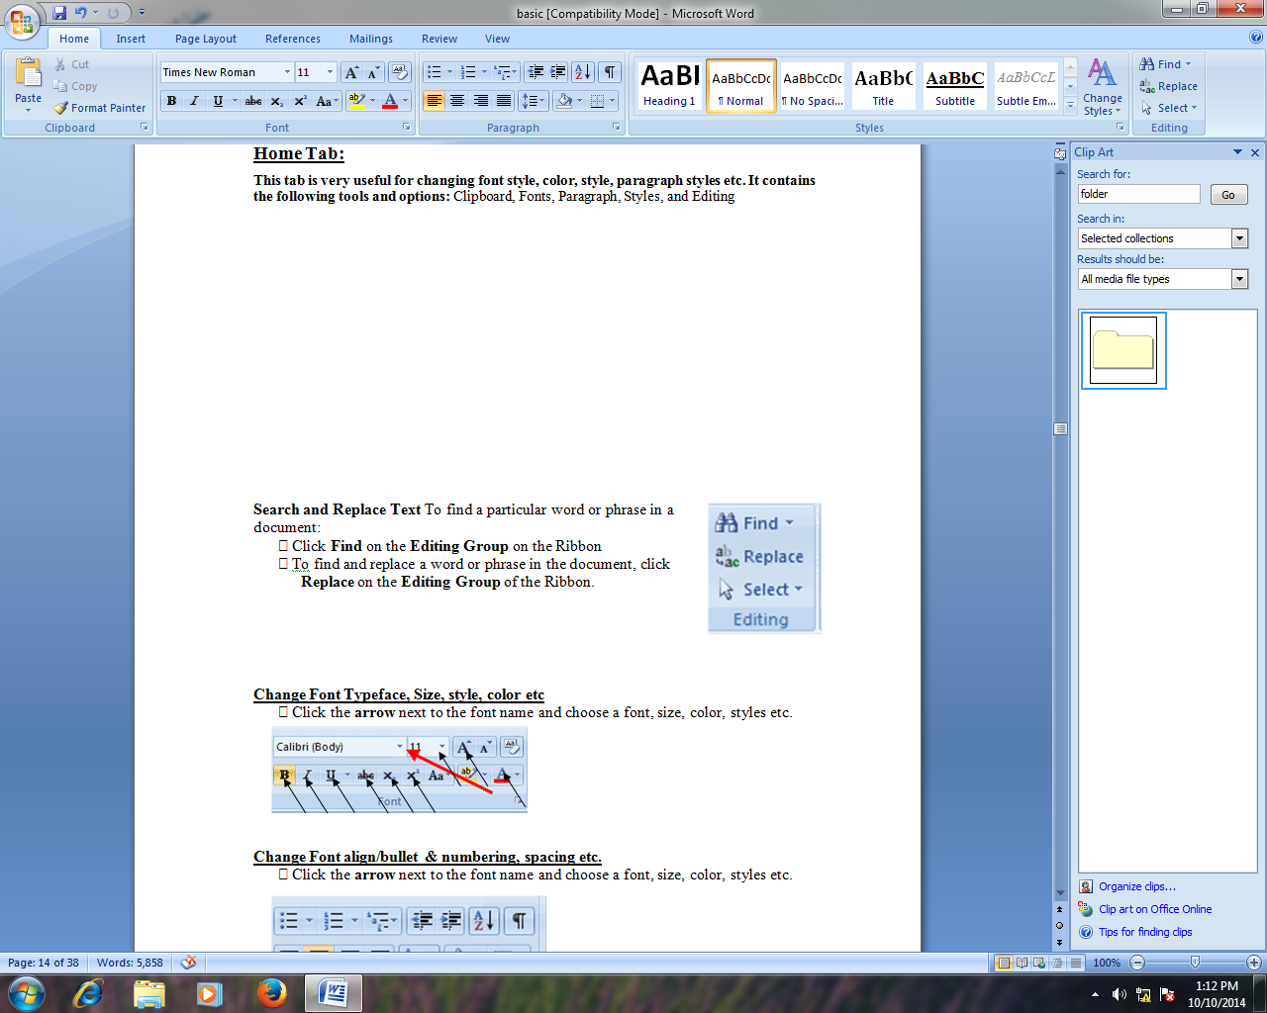This tab is very useful for changing font style, color, paragraph styles etc. It contains the following tools and options: Clipboard, Fonts, Paragraph, Styles, and Editing

**Copy and paste:**

It is used to copy the selection and put it on the clipboard then make them other copies. It helps us to make the text, object copies/duplicate content. Once content is copied it should be paste to make duplicate.

Process

* 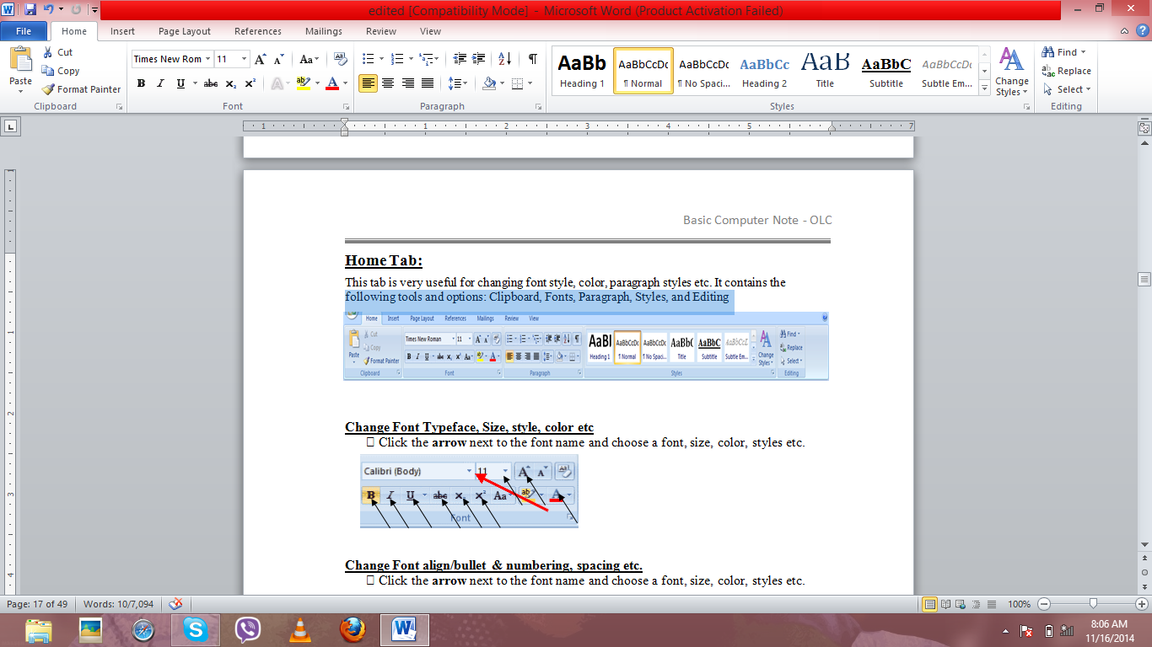Select text/object
* Place click on insert tab
* Click on copy
* Place the cursor and click on paste

**Cut and paste:**

It is uses to cut the selection and put it on the clipboard/make them other copies. It helps us to make the text, object copies/duplicate content. Once content is cut it should be paste to make duplicate.

Process

* Select text/object
* Place click on insert tab
* Click on cut
* Place the cursor and click on paste

**Change Font Typeface, Size, style, color etc**

􀂃 Click the **arrow** next to the font name and choose a font, size, color, styles etc.

Bold /italic/underline/strikethrough/subscript/superscript the text

* Select text
* Click on insert tab
* Click on related button as displayed on the picture



**Change Font align/bullet & numbering, spacing etc.**

􀂃 Click the **arrow** next to the font name and choose a font, size, color, styles etc.



**Apply Styles** There are many styles that are already in Word ready for you to use. To view the available styles click the **Styles** dialog box on the Styles Group in the Home Tab. To apply a style:

􀂃 Select the text

􀂃 Click the **Styles** Dialog Box

􀂃 Click the **Style** you choose

**Find**

To find a particular word or phrase in a document:

* Click on Home tab
* click on find from the displayed ribbon
* Type required word or phrase
* Click on reading highlight/find in/ find next button as required.

***Reading Highlight***

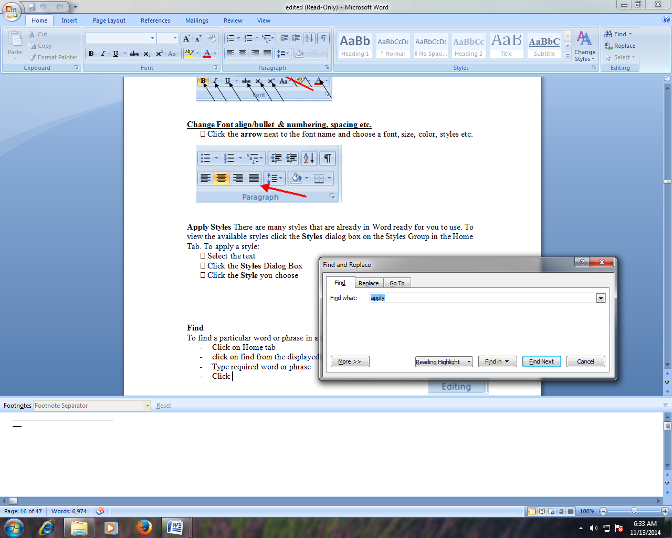Select **Reading highlight** to highlight the required word or phrase in a document.

***Find in***

Select **find in** to find the word or phrase on the main document, headers etc.

***Find Next***

Use to find and highlight the required word or phrase in a document and move to next word/phrase.

**Replace**

It helps to find a particular word or phrase in a document and replace new word or phrase in the document:

* Click on Home tab
* Click on replace form the displayed ribbon
* Type required word or phrase on find what text box and new word or phrase on replace with text box
* Click on replace / replace all button.

**Select**

It helps to select the whole document content, particular objects like pictures or group of objects like shapes

* Click on Home tab
* Click on select from ribbon
* Click on select all to select the whole document content, select objects to select shapes or pictures or select text with similar formatting to select contentshaving similar format

**Important shortcuts**:

Bold Text ctrl + b Italic ctrl + i

Underline ctrl + u Double underline ctrl + shift + d

Left align ctrl + l Center align ctrl + e

Right align ctrl + r Justify align ctrl + j

Find ctrl + f Replace ctrl + h

Go to ctrl + g Undo ctrl + z

Repeat/redo ctrl + y subscript ctrl + =

Superscript ctrl + shift + = copy ctrl + c

Paste ctrl + v cut ctrl + x

Select all ctrl + a

Insert Tab:

This tab is used to insert table, picture, clip art, autoshapes, smart art, chart, hyperlink, bookmark, header fotter, pagenumber, textbox, word art, object, symbol and many more.



**Create a Table:** Use to create a table:

􀂃 Place the cursor on the page where you want the new table

􀂃 Click the **Insert** Tab of the Ribbon

􀂃 Click the **Tables** Button on the Tables Group. You can create a table one of the ways:

􀂃 Highlight the number of row and columns

􀂃 Click **Insert Table** and enter the number of rows and columns

􀂃 Click the **Draw Table**; create your table by clicking and entering the rows and columns

􀂃 Click **Quick Tables** and choose a table

or,

**First step:**

* Click on insert tab
* Click on table button
* Hover the mouse and click as required

**Second step:**

* Click on insert tab
* Click on table button
* Click on insert table option
* Type required column and row
* Click on ok

**Third step:**

* Click on insert tab
* Click on table button
* Click on draw table option
* Hold down left button and design from the given pencil

(to apply more features on table like background color, merge cell, split cell, insert column and row etc, select **table tools’**design and format tab)

Some of the designing and formatting steps of table tools are:

Design Tab:

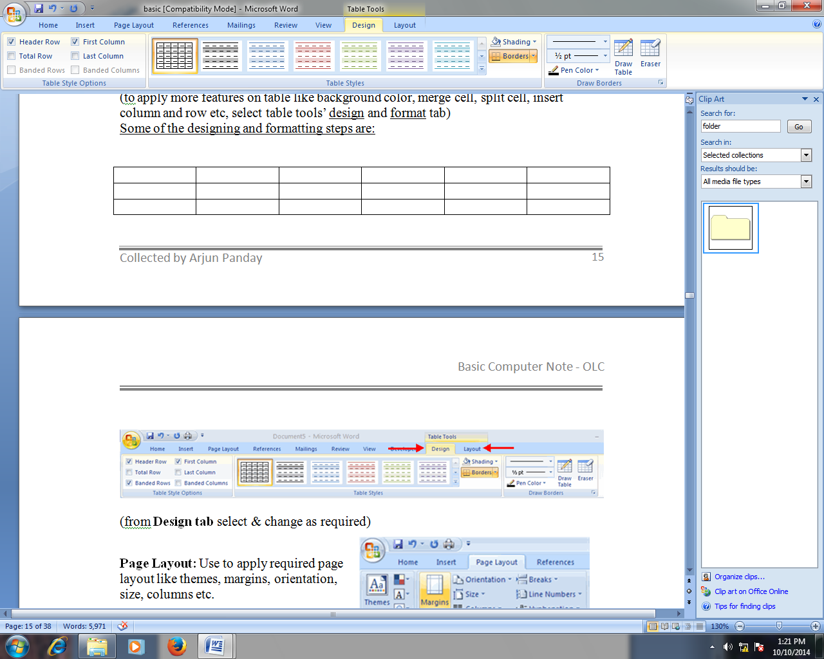

color the background behind the text

use to visual style of table

LayoutTab:

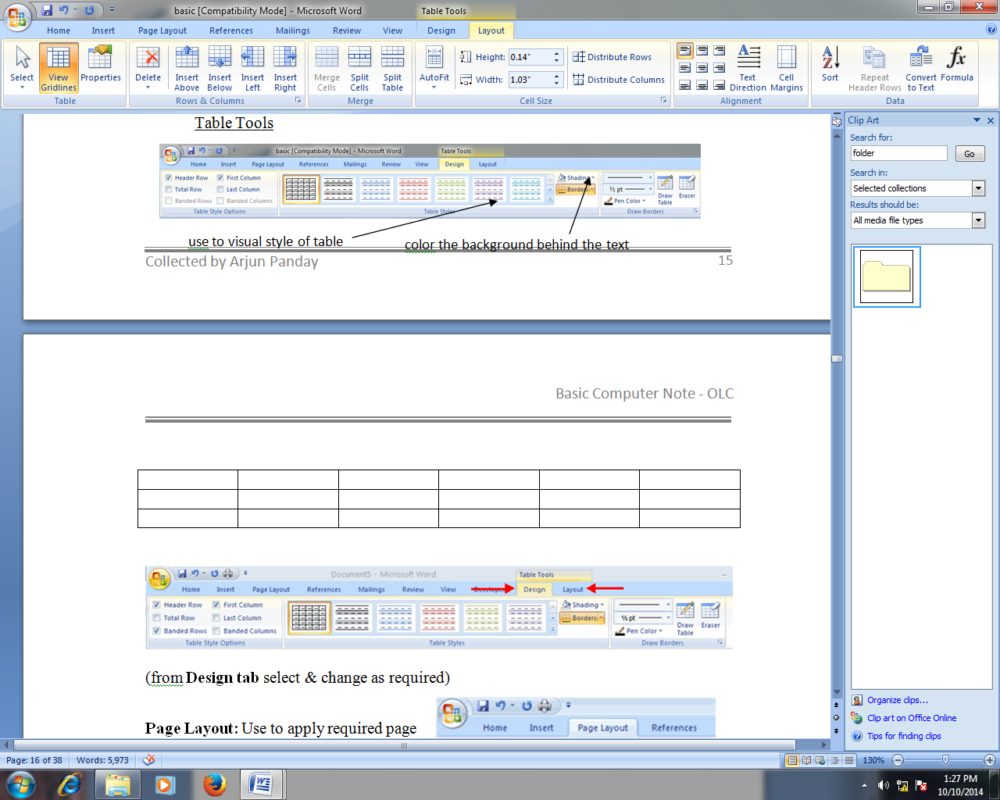**Insert Above**

This button helps to add a new row directly above the select row.

**Process:**

* place the cursor on required cell or select row
* click on layout tab
* click on insert above button

**Insert below**

This button helps to add a new row directly below the select row.

**Process:**

* place the cursor on required cell or select row
* click on layout tab
* click on insert below button

**Insert left**

This button helps to add a new column directly to the left of the select column.

**Process:**

* place the cursor on required cell or select column
* click on layout tab
* click on insert left button

**Insert right**

This button helps to add a new column directly to the right of the select column.

**Process:**

* place the cursor on required cell or select column
* click on layout tab
* click on insert right button

**Merge Cell:**

It is used to merge the select cells to one.

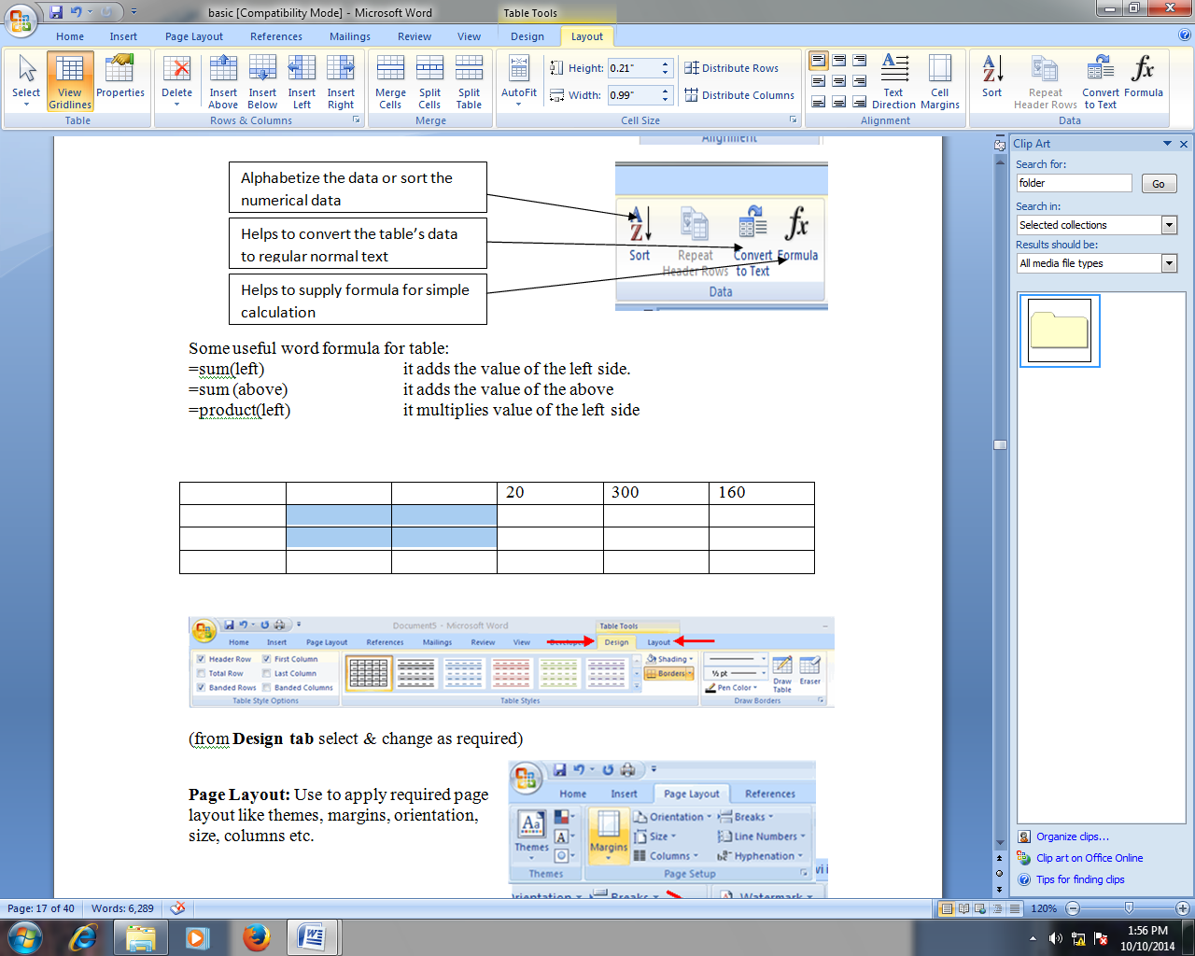 **Process:**

* select the required cell
* click on layout tab
* click on merge cell

**Split Cell:**

It is used to split/divide the select cells to multiple cell (column or row).

**Process:**

* select the required cell
* click on layout tab
* click on split cell

**Split table:**

It is used to split/divide the select table to two tables.

**Process:**

* select the row
* click on layout tab
* click on split table

How to change data alignment, direction of table:

**Process:**

* select the required data of the table
* click on layout tab
* click on required alignment style as displayed on the figure



Alphabetize the data or sort the numerical data

Helps to convert the table’s data to regular normal text

Helps to supply formula for simple calculation

**Some useful formula for table:**

=sum(left) it adds the value of the left side.

=sum (above) it adds the value of the above

=product(left) it multiplies value of the left side

**Insert picture to our document**

**Process:**

* Click on insert tab from the ribbon
* Click on picture button
* Select location and file
* Click on insert button

(Select picture tools’ format tab and apply brightness, contrast, color mode, border style, etc.)

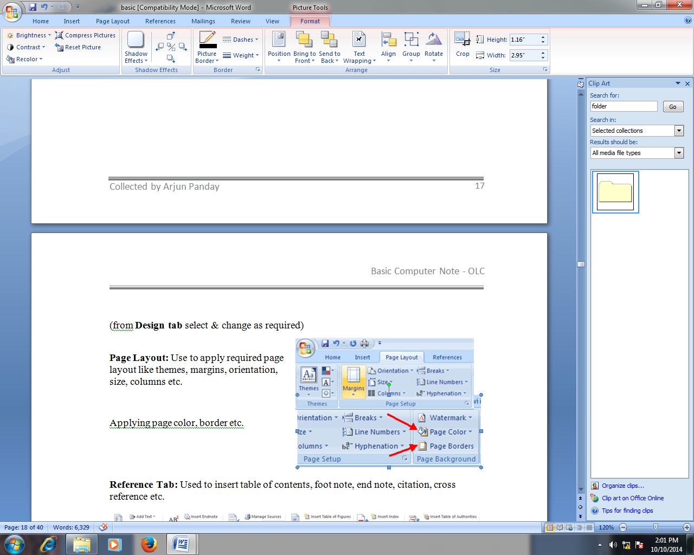

**Adjust Effect:**

It is used to add a shadow to the shape or picture.



use to increase/decrease brightness of picture

use to increase/decrease contrast of picture

use to reset modified picture

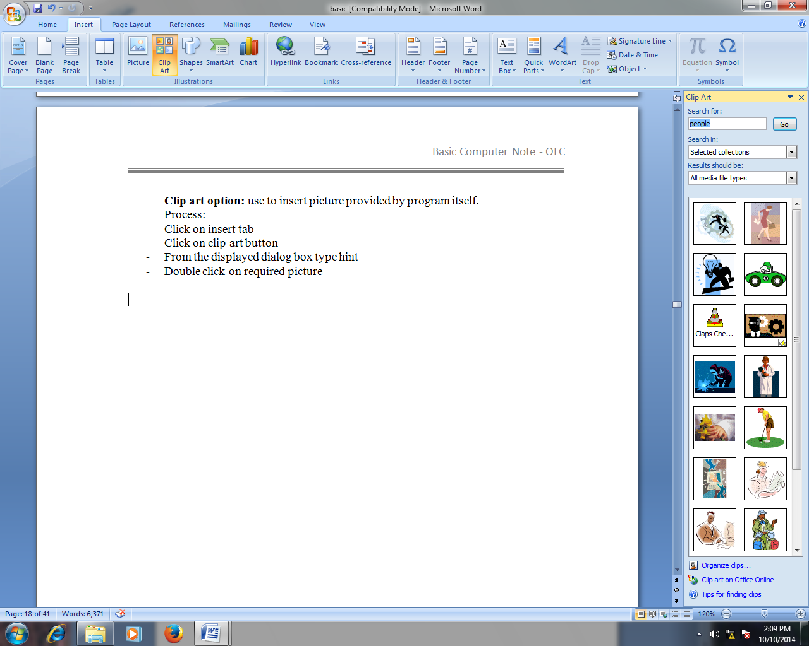**Clip art option:** use to insert picture provided by program itself like drawing, photography etc.

Process:

* Click on insert tab
* Click on clip art button
* From the displayed dialog box type hint
* press enter key or go button
* Double click on required picture

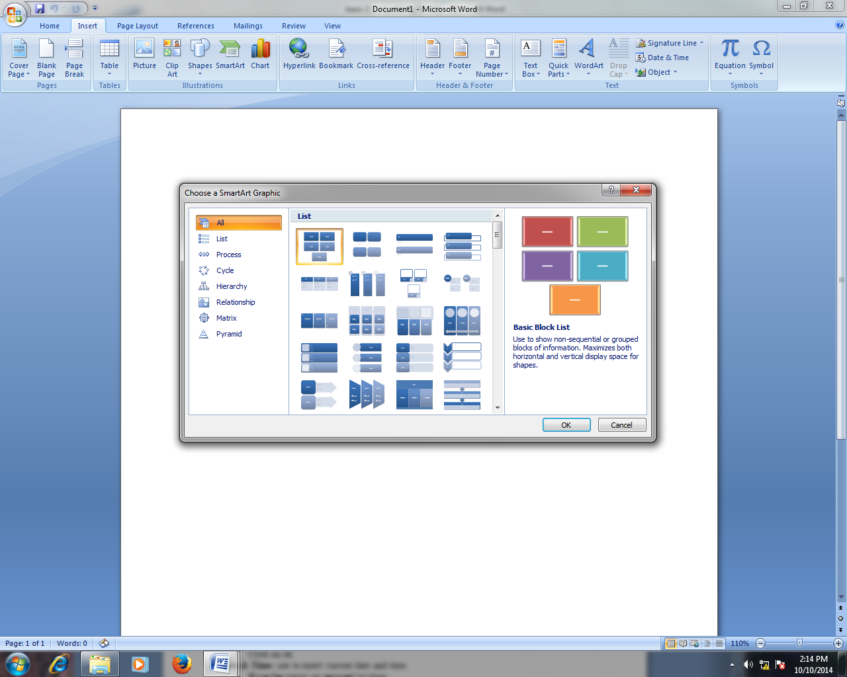

**Smart Art:**

**Use to insert visually communicable figures like chart, Venn diagram,**

**Process:**

* Click on insert tab from the ribbon
* Click on smart Art button
* Select type and design as required

(Select design and format tab for more editing and designing)

**Chart button:** use to insert chart to illustrate and compare data. Using this button we can insert chart like column chart, pie chart, line chart, area , bar char etc.

* Click on insert tab from ribbon
* Click on chart button
* Select required chart style
* Click on ok
* Apply requred data on the displayed excel sheet, then close that

***Once the chart is inserted then Chart tools with design, layout and format tab is displayed. It helps us to change and edit the design, layout and format of the chart.***

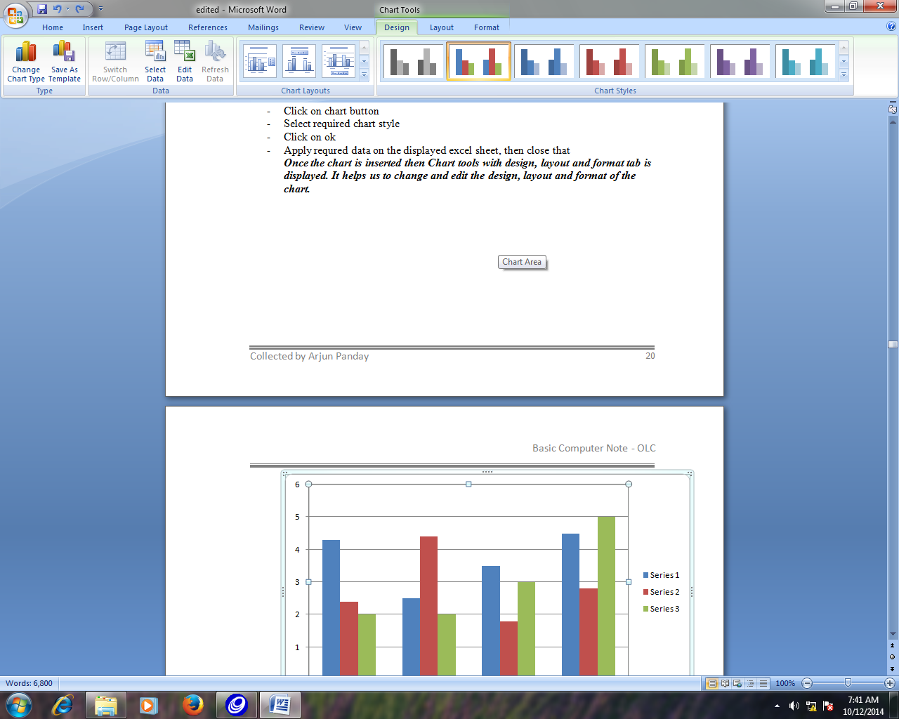**Design Tab:**

Change the overall visual style of the chart

**Change Chart type Button:** It is used to change the desined chart to new chart type like pie chart to column chart, column chart to pie chart etc.

**Process:**

* Select required chart
* Click on design tab from the ribbon
* Click on change chart type
* From the displayed chart style select related chart then ok

**Edit Data Button:** It helps to modify the chart according to the new data.

**Process:**

* Select required chart
* Click on design tab from the ribbon
* Click on edit data button
* From the displayed sheet change data of the chart then close that

**Layout Tab:**

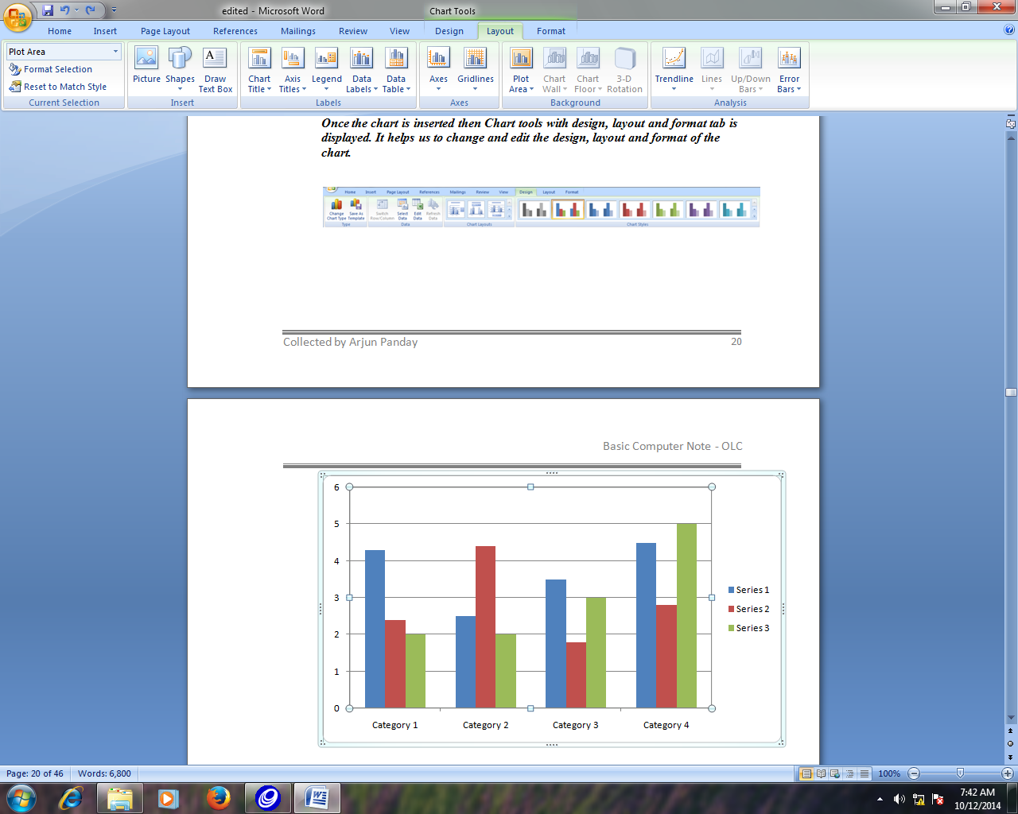

Helps to change the title of the chart

Helps to change legend position of the chart chart

Helps to add the data table below to the chart

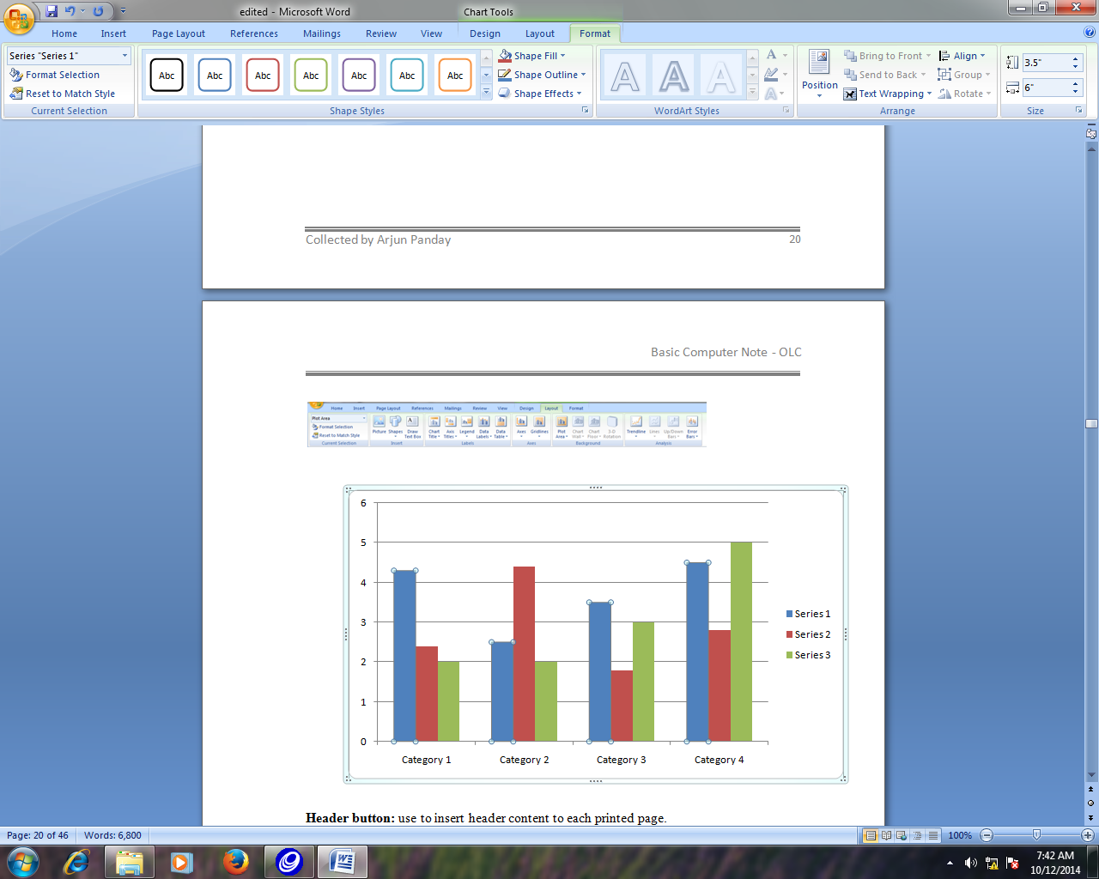 **Format Tab:**

Helps to change the Visual style of the chart line and shape the chart

Helps to change shpe fill with color, gradient, effect etc.

Helps ot change the outline style, color, weight etc.

Helps ot change the visual style to the text

**Header button:** use to insert header content to each printed page.

* Click on insert tab from ribbon
* Click on header button
* Select required header style
* Type required text

**Footer button:** use to insert footer content to each printed page.

* Click on insert tab from ribbon
* Click on footer button
* Select required header style
* Type required text

**Page Number:** use to insert page number to document.

* Click on insert tab from ribbon
* Click on page number button
* Select required style

How to delete inserted page number?

process:

* Click on insert tab from ribbon
* 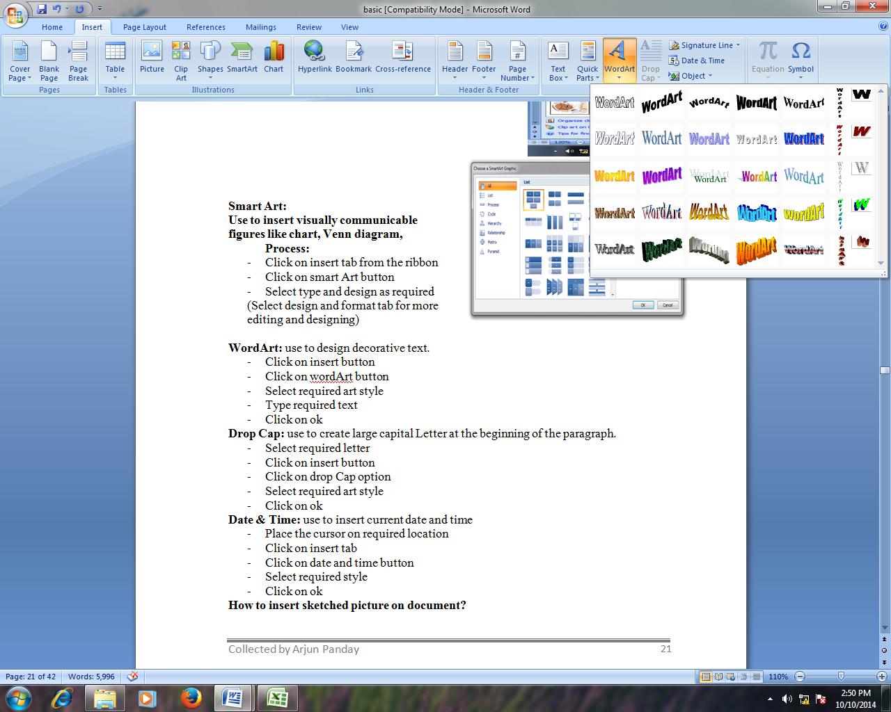Click on page number button
* click on remove page number option

**WordArt:** use to design decorative text.

* Click on insert button
* Click on WordArt button
* Select required art style
* Type required text
* Click on ok

**Drop Cap:** use to create large capital Letter at the beginning of the paragraph.

* Select required letter
* Click on insert button
* Click on drop Cap option
* Select required art style
* Click on ok

**Date & Time:** use to insert current date and time

* Place the cursor on required location
* Click on insert tab
* Click on date and time button
* Select required style
* Click on ok

**How to insert sketched picture on document?**

* 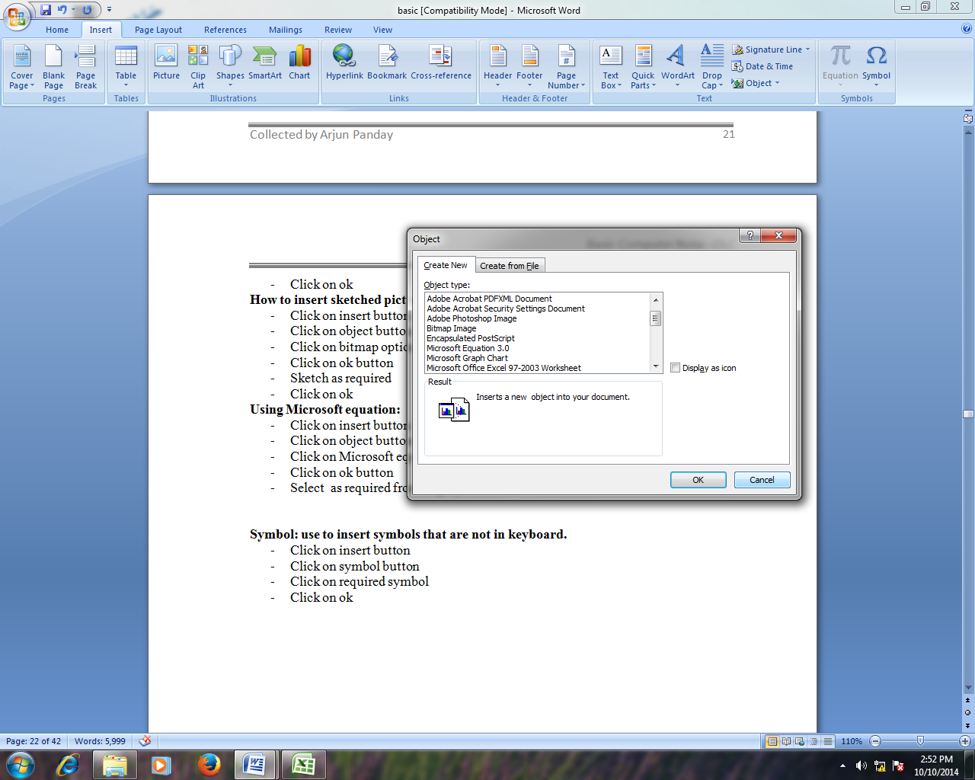Click on insert button from ribbon
* Click on object button
* Click on bitmap option
* Click on ok button
* Sketch as required
* Click on ok

**Using Microsoft equation:**

* Click on insert button
* Click on object button
* Click on Microsoft equation option
* Click on ok button
* Select as required from displayed tool bar

**Symbol: use to insert symbols that are not in keyboard.**

* Click on insert button
* Click on symbol button
* Click on required symbol
* Click on ok

Page Layout

Use to apply required page layout like themes, margins, orientation, size, columns etc.

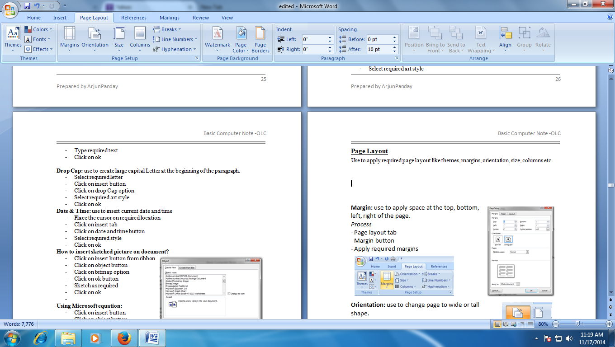

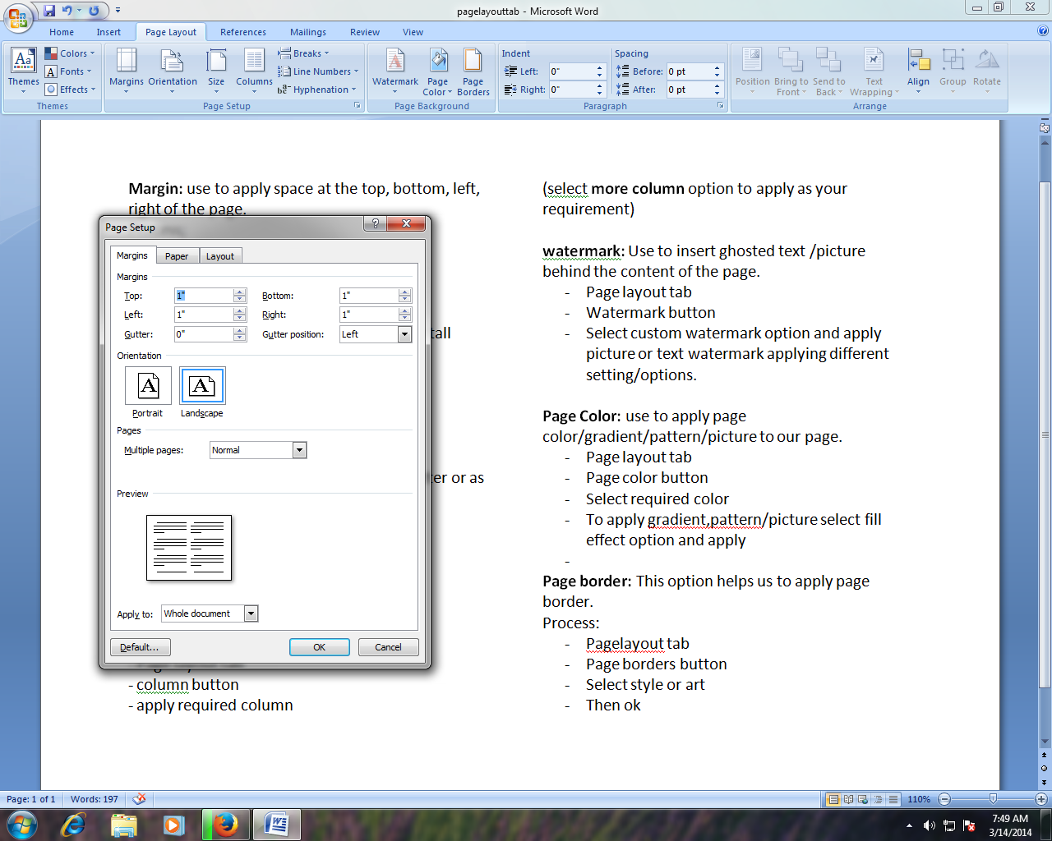**Margin:** use to apply space at the top, bottom, left, right of the page.

*Process*

- Page layout tab

- Margin button

- Apply required margins



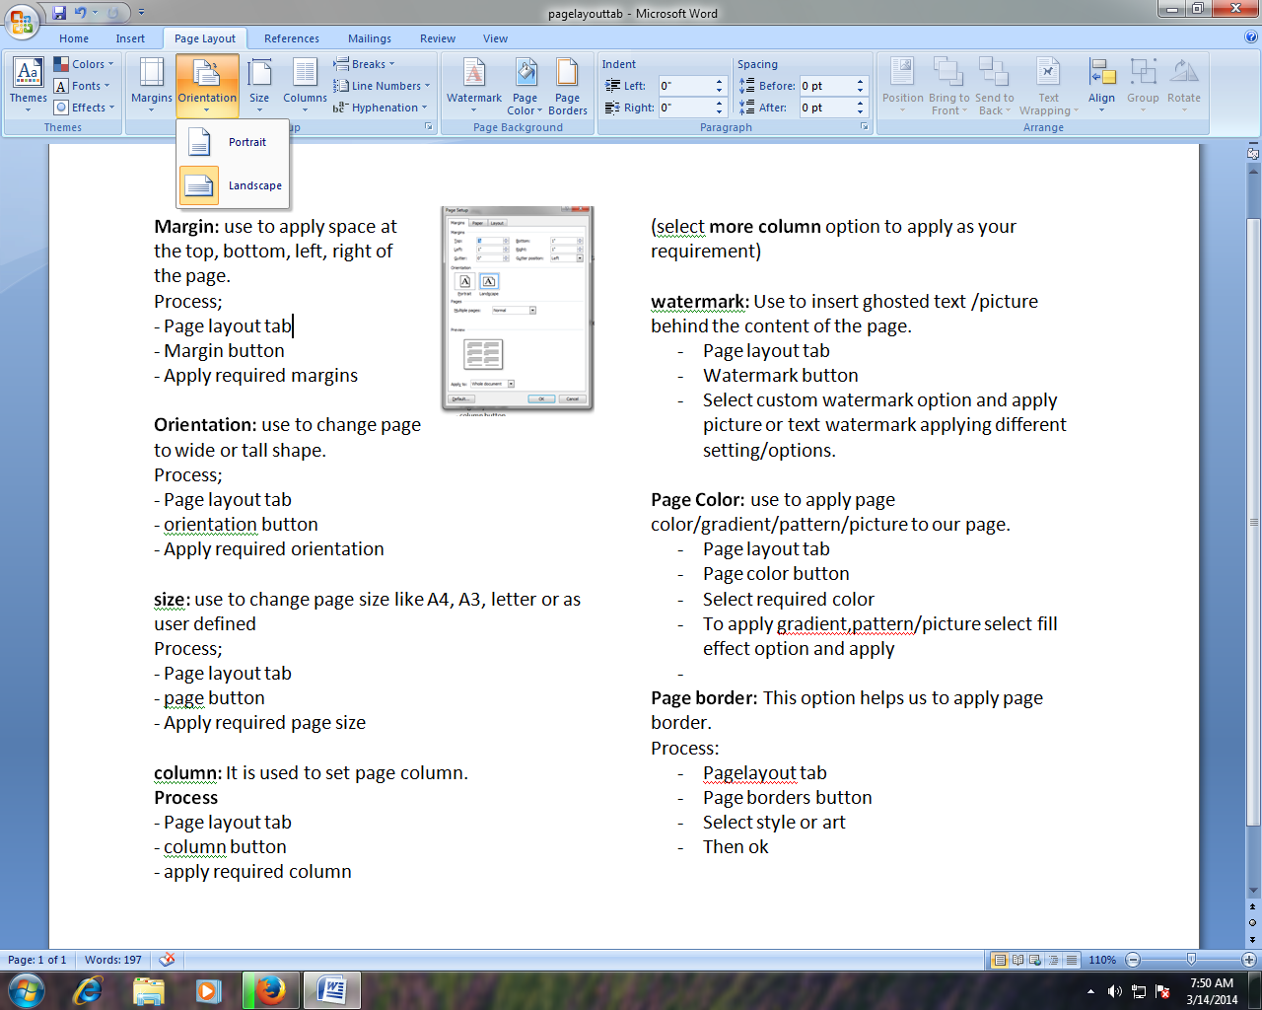**Orientation:** use to change page to wide or tall shape.

*Process:*

- Page layout tab

- orientation button

- Apply required orientation

**size:** use to change page size like A4, A3, letter or as user defined

*Process:*

- Page layout tab

- page button

- Apply required page size

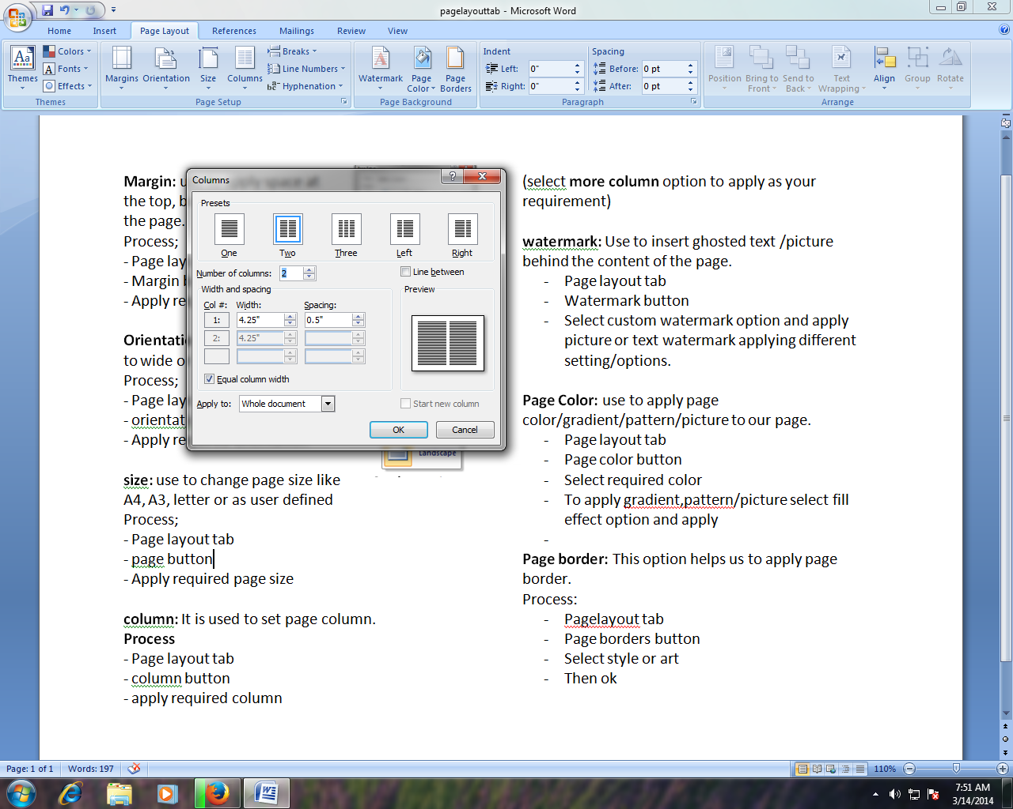

**Column:** It is used to set page column.

*Process*

- Page layout tab

- column button

- apply required column

(select**more column** option to apply as your requirement)

**watermark:** Use to insert ghosted text /picture behind the content of the page.

*Process:*

* Page layout tab
* Watermark button
* Select custom watermark option and apply picture or text watermark applying different setting/options.

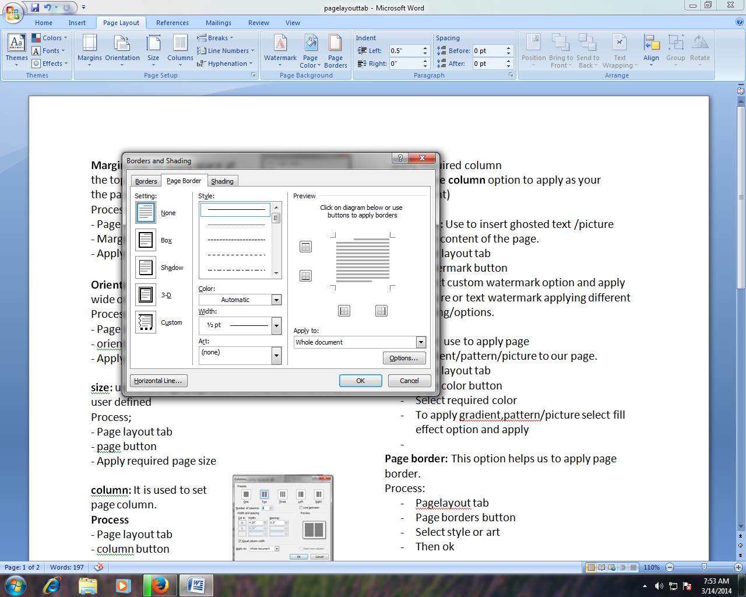**Page Color:** use to apply page color/gradient/pattern/picture to our page.

*Process:*

* Page layout tab
* Page color button
* Select required color
* To apply gradient, pattern/picture, select fill effect option and apply

**Page border:** This option helps us to apply page border.

*Process:*

* Pagelayout tab
* Page borders button
* Select style or art
* Then ok

Reference Tab

****Used to insert table of contents, foot note, end note, citation, cross reference, etc.

**Table of content:** use to apply table of content according to our heading with page number to our document.

* First select head/title and apply related heading from home tab
* Reference tab
* Table of contents
* Apply required style

**Update table**: It is used to change table of content after adding more content to our document if table of content is already inserted.

Select table of content

* Click on reference tab
* Click on update table button

**References &Citations :**Microsoft word offers great tools for citing sources, creating a bibliography, and managing the sources. The first step to creating a reference list and citations in a document is to choose the appropriate style that you will be using for formatting the citations and references.

**Citations** To insert a citation in the text portion of your document:

* Click the References Tab on the Ribbon
* Click the Insert Citation Button on the Citations & Bibliography Group
* If this is a new source, click New Source
* If you have already created this source, it will in the drop down list and you can click on it

**Insert caption**: use to apply object/pictures caption

* Select picture/object
* Reference tab
* Insert caption button
* Type text then ok

**Insert table of figures**

* click on reference tab
* Insert table of figures
* Apply as required

Mailings Tab

Used to insert Envelops, Labels etc as well as provides powerful features mail merge.

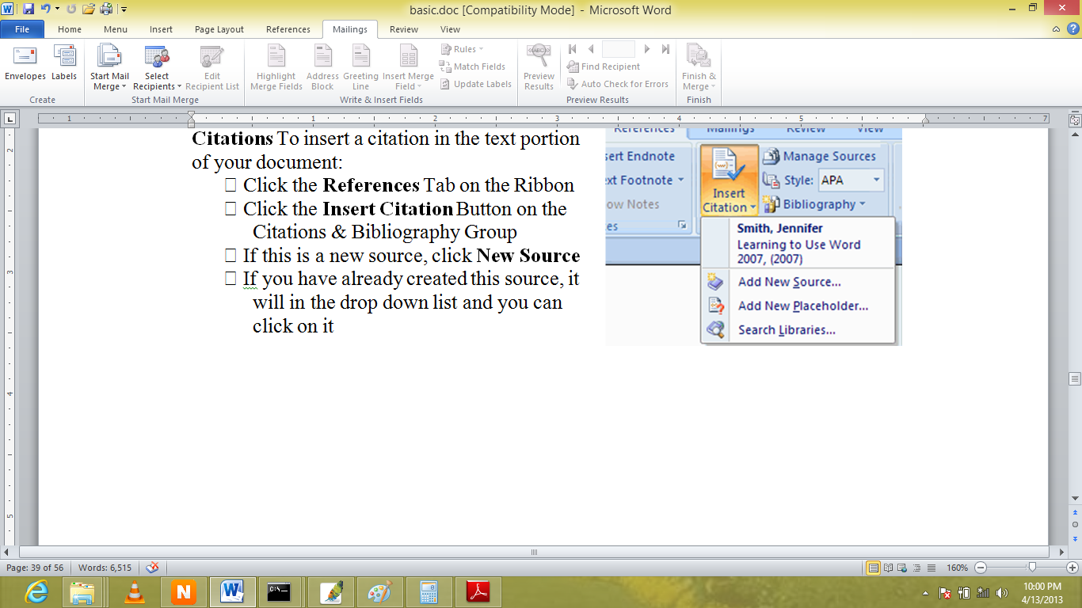

Mail Merge:

􀂃 Click the **References** Tab on the Ribbon

􀂃 Click the **Select Recipients** Button

􀂃 Select use existing list

􀂃 Select required location and file

􀂃 Click the **open** Button

􀂃 Then other option and button will be highlighted

􀂃 Click the **insert Merge Field** Button and select required field to insert

􀂃 Click the **Finish & Merge** Button and select required option

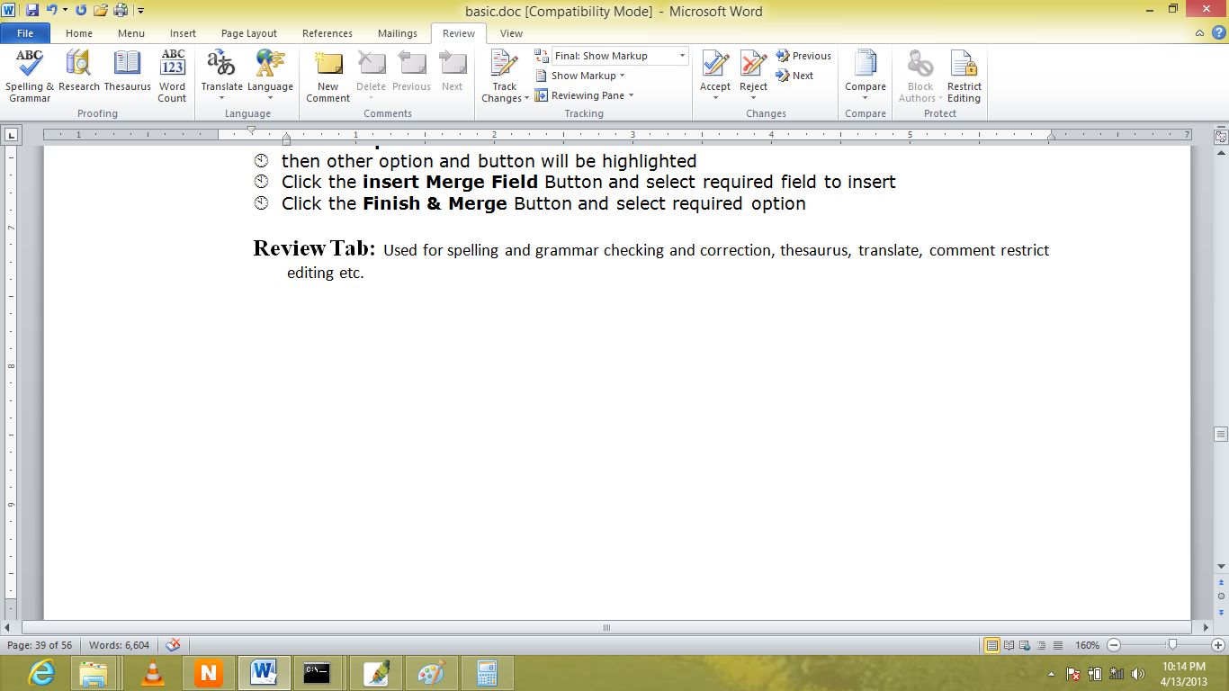Review Tab

Used for spelling and grammar checking/correction, thesaurus, using translation, comment, restrict editing etc.

**Spelling & Grammar Checking**

* Click on review tab
* Spelling and grammar button
* Select required suggestion and click on change button or ignore button as required

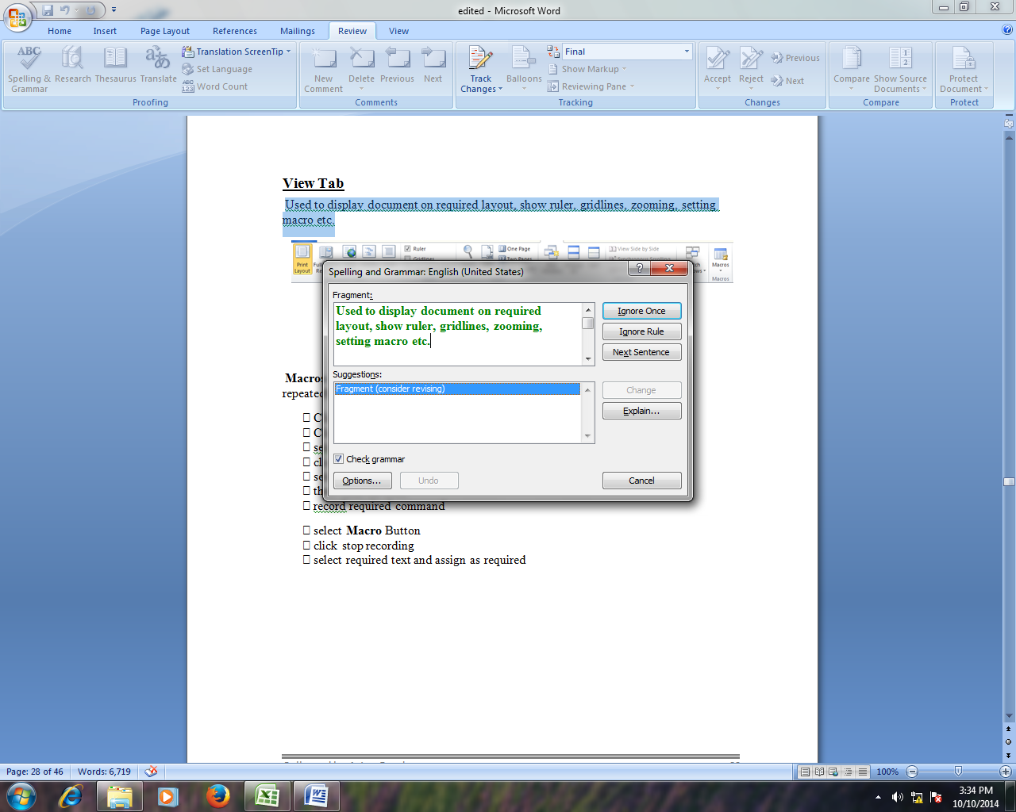

**Thesaurus:**

Use to find synonyms and antonyms of the word.

* Click on review tab
* Click on thesaurus button

**Comment:** use to display applies comment on the select text/paragraph.

* Click on review tab
* Click on New comment button
* Type required comment

(Right click on required comment and click on delete comment to delete that comment)

**Protect Document:** use to protect document from unauthorized access and editing.

* Click on review tab
* Click on protect document
* Click on restrict formatting and editing option
* Tick mark the check box of allow only this type of editing in the document option
* Select as required (example: read only)
* Click on yes, start enforcing protection button
* Type required password then
* Click on ok button

**How to remove the restrictions that is protected?**

* Click on review tab
* Click on protect document
* Click on restrict formatting and editing option
* Click on stop protection button
* Type required password
* Click on ok button

View Tab

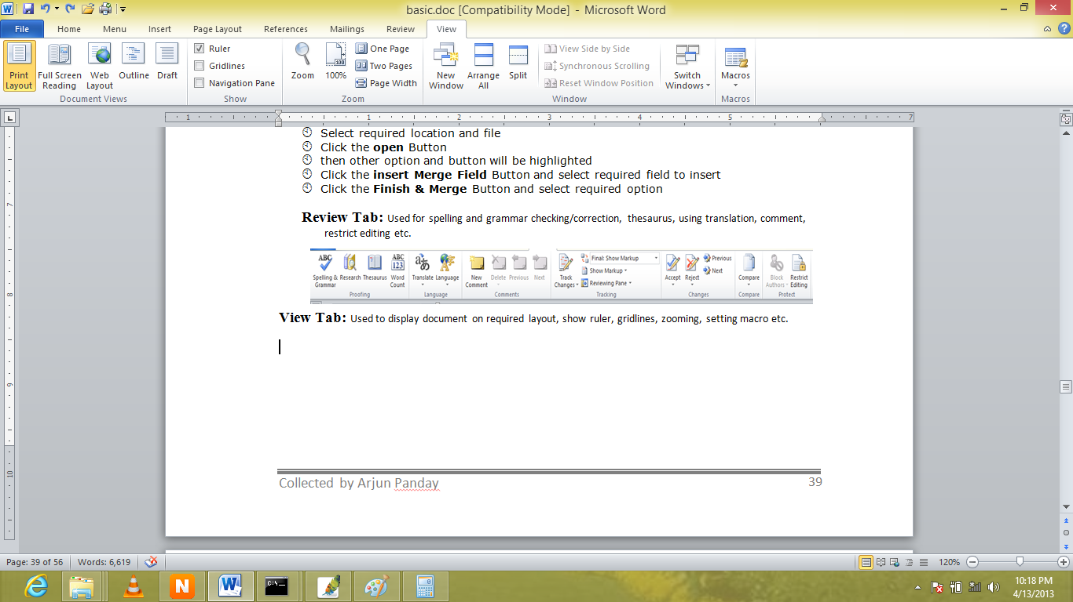Used to display document on required layout, show ruler, gridlines, zooming, setting macro etc.

**Macros**: use to record and assign more command to required shortcut and use repeatedly.

􀂃 Click the **View** Tab on the Ribbon

􀂃 Click the **Macro** Button

􀂃 select use record macro form the list

􀂃 click on keyboard option

􀂃 select required categories and commands and assign shortcut on its box

􀂃 then click on close

􀂃 record required command

􀂃 select **Macro** Button

􀂃 click stop recording

􀂃 select required text and assign as required